Title of the Event | Orientation on Project Report writing | 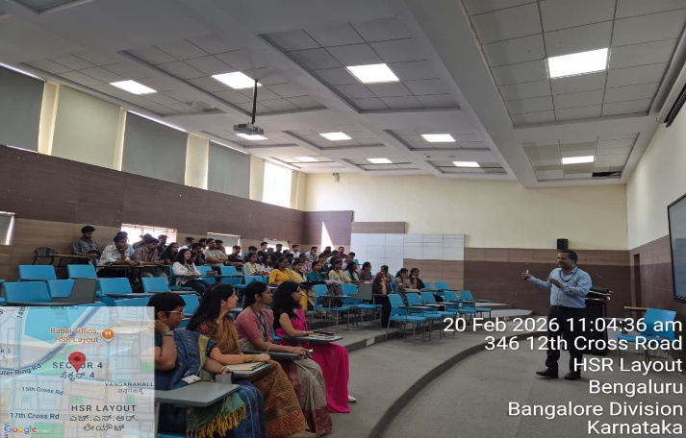
Day and Date | 20 February 2026
Venue (With all details ) | Room No- 407
In collaboration with ( if any)
Details of Resource Person With Designation | Dr.Praveen Kumar Sinha | 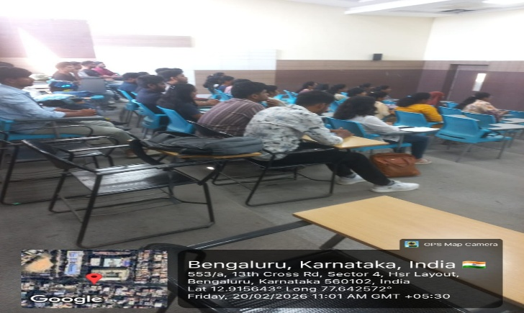
Organizing Department/Coordinators | Business Management ,
Course and semester | MBA III Sem
No of Students & Faculty Participants | 55

Coordinator HoD Vice-Principal Principal

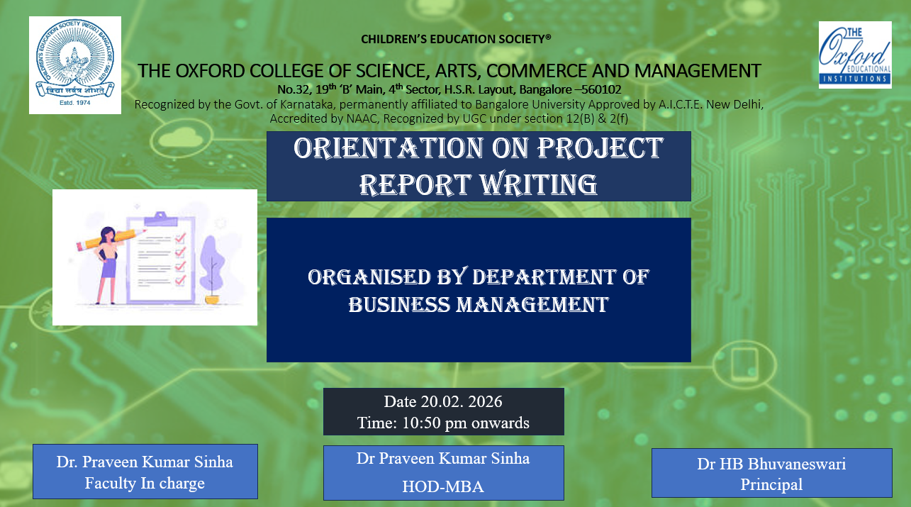
. Introduction
Project Report Writing is an important academic requirement for MBA III Semester students as per Bangalore University guidelines. To guide students in preparing their project work effectively, a session on “Project Report Writing” was conducted by Dr. Praveen Sinha .
Description of the Activity
The session was conducted for MBA III Semester students. Dr. Praveen Sinha explained the structure and format of the project report including title page, certificate, declaration, chapters, bibliography, and annexure. He also guided students on research methodology, data collection, referencing style, plagiarism norms, and viva-voce preparation. The session was interactive, and students clarified their doubts regarding report submission guidelines.
Outcome of the Activity
The session helped students understand the proper format prescribed by Bangalore University. It enhanced their research writing skills, clarity in methodology, and confidence in preparing their final project report.
Conclusion
The Project Report Writing session was a valuable academic initiative. It provided clear guidance to MBA III Semester students and ensured better preparation for project submission as per university guidelines.

